ALLOTMENT SITE & PLOT COMPETITION 2016

The annual allotment competition is designed to find best kept allotment sites and plots in the Borough. It is an opportunity for societies and plot holders to compete in a friendly competition for cash prizes and trophies.

Large and small sites are judged separately We need more small sites to participate so if your site is 250 poles or less please do take up the challenge; you are in with an excellent of winning. Small sites are listed in the competition schedule.

Whether you are a regular competitor or have never entered before, I urge you to take part. No site or plot is perfect so please give it a go. Promote the plot competition among your members and encourage them to enter. And don’t forget to enter your own site this year.
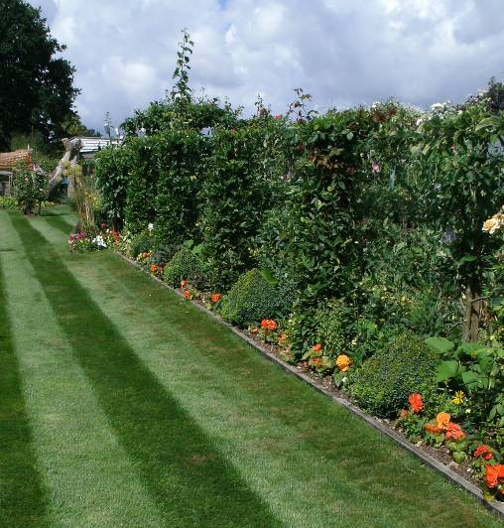
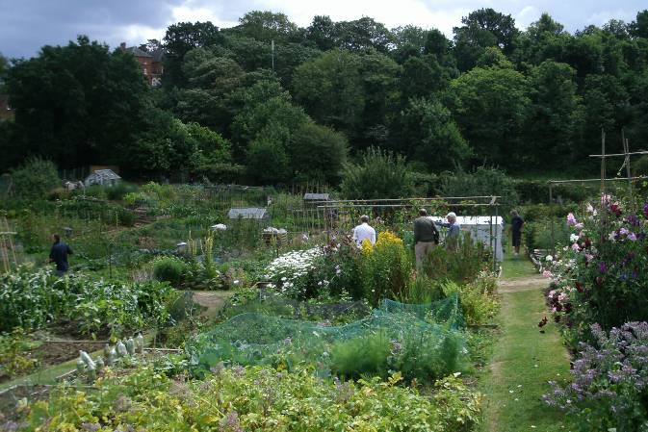
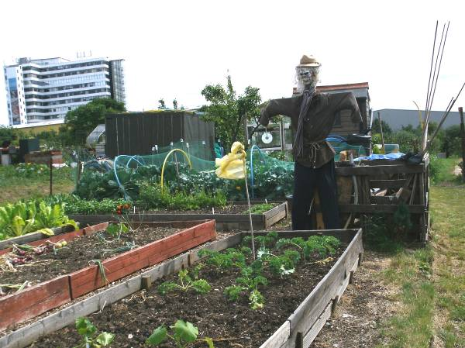
Please send your entries on the attached form no later than Sun 7th July June _____________________

The Ted Green Award is given to the society showing the most outstanding allotment community initiative during the previous twelve months.

Details will follow in July. Judging will take place in September.

